**CS 487 DATA SECURITY**

**HOP09 – Deploy Peering**

2/9/2021 Developed by Mary Oh

Center for Information Assurance (CIAE) @City University of Seattle (CityU)

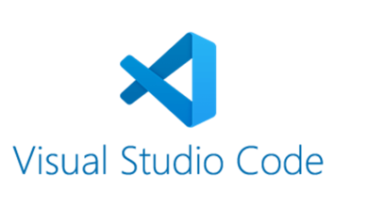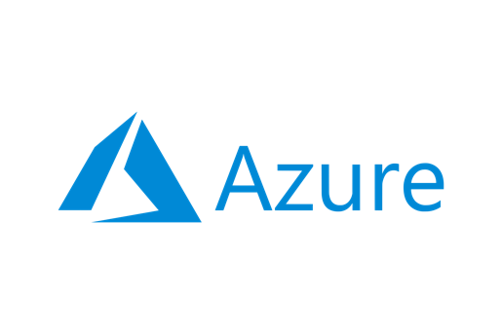

**Before You Start**

* Version numbers may not match with the most current version at the time of writing. If given the option to choose between stable release (long-term support) or most recent, please choose the stable release rather than beta-testing version.
* This tutorial targets Windows users and MacOS users.
* There might be subtle discrepancies along the steps. Please use your best judgement while going through this cookbook style tutorial to complete each step.
* For your working directory, use your course number. This tutorial may use a different course number as an example.
* The directory path shown in screenshots may be different from yours.
* If you are not sure what to do or confused with any steps:
  + Consult the resources listed below.
  + If you cannot solve the problem after a few tries, ask a TA for help.

**Learning Outcomes**

* Learn how to use Visual Studio Code to deploy Backup Policy

**Resources**

* Microsoft Azure - [https://azure.microsoft.com/](https://azure.microsoft.com/en-us/overview/what-is-azure/?&ef_id=Cj0KCQiAlsv_BRDtARIsAHMGVSac9cd8I7htfl0EVYTYDUBxYJ7mEqQ6dB5bRem2ziaBp-j1Di4wui8aAivlEALw_wcB:G:s&OCID=AID2100131_SEM_Cj0KCQiAlsv_BRDtARIsAHMGVSac9cd8I7htfl0EVYTYDUBxYJ7mEqQ6dB5bRem2ziaBp-j1Di4wui8aAivlEALw_wcB:G:s&gclid=Cj0KCQiAlsv_BRDtARIsAHMGVSac9cd8I7htfl0EVYTYDUBxYJ7mEqQ6dB5bRem2ziaBp-j1Di4wui8aAivlEALw_wcB)
* Microsoft Documentation - <https://docs.microsoft.com/>

**What is Azure?**

Azure cloud platform is cloud services designed to help bring new solutions to life. You can build, run, and manage application across multiple clouds, on-premises, and at the edge, with the tools and frameworks of your choice.

**What is Virtual Network Peering?**

Virtual Network Peering lets you seamlessly connect two or more Virtual Networks in Azure. They appear as one for connectivity purposes. Like the traffic between virtual machines in the same network, traffic is routed through Microsoft’s private network only.

**Using ARM template**

1. Download the attached json files.
2. Open the json files with Visual Studio Code.
3. Open the integrated Visual Studio Code terminal using ctrl + ` key.
4. Sign in using your Azure account information. This will open up a new window to sign in.



1. Create the resource group. Use the resource group name “CityU-CS487-Winter2021” and location “westus2”.

**Deploy template to Azure**

1. Deploy the template. Ensure you are in the correct directory where the file is saved.

*Note: By now, you should know how to create resource group and deploy the template using your terminal. Please include screenshots of your successful creation of resource group and deployment in your write-up.*

1. Verify the VNets and the peering of the VNets is successful in your Azure portal. Include screenshots in your write-up.
2. To avoid incurring any unnecessary fees, clean up resources. Delete your virtual networks.
3. Delete your resource group using your terminal. Include a screenshot.
4. Verify cleaning up of resources is successful. Head to your Azure in your web browser and refresh. The resource group should not be showing.

**Questions you can answer for submissions:**

1. **Knowledge:** Why is Virtual Network important?
2. **Knowledge:** What is Peering? Provide an analogy to understand it better.
3. **Knowledge:** What are the benefits of vNet peering?
4. **Knowledge:** What are the two types of vNet peering and the differences?
5. **Application:** When do you want to use vNet peering? Why?

**Push your work to GitHub**

1. Open the integrated Visual Studio Code terminal using ctrl + ` key. Make sure you are in the right path.
2. Type the following command:

git add . (to copy all changes you have made)

git commit -m “Submission for Module 9 - YourGitHubUsername” (To add a message to your submission)

git push origin master (to upload your work to Github)